Analysis on the Impact of Temperature as an Indicator of Climate Change on Agricultural Productivity

Kha-Ai Tran

GEOG788P

Fall 2021

# Introduction and Background

Climate change affects different geographic regions in different ways, due to a variety of factors – physical geography, location, human activity, land cover, water availability, and more. In the United States, climate change is known to bring higher average temperatures, more precipitation, longer growing seasons, and introduce more invasive species, such as pests (Lane et al, 2018). Consequences of such changes have already been experienced by the agricultural industry. For example, in the Northeast U.S., grape producers have experienced losses in crop yield due to abnormal fluctuations in temperature in late winter (Lane et al, 2018). In the Midwest U.S., climate change impacts are predicted to increase variability in agricultural production (Pryor et al, 2014). In some circumstances, increases in average temperature may expand the potential for agricultural production in some regions. However, extremes in temperature in either direction may increase variability in agricultural production further. Some regions that will experience colder extremes may see a reduction in agricultural production.

Agriculture also contributes to climate change – primarily through the emission of greenhouse gases involved in agricultural activities. About 17% of greenhouse gas emissions come directly from agriculture, and an additional 7-14% of greenhouse gas emission result from land use changes related to agriculture (OECD, 2016). Thus, it is important to understand how climate change may impact agricultural production and how players in agriculture may reinforce or balance climate change itself.

# Problem Statement

The objective of this analysis is primarily to analyze the impact of temperature on agricultural productivity, where average temperature is used as a measure of climate change. Secondarily, the analysis also examines other proxy measures of agricultural productivity and responses to climate change related to agriculture. This is an attempt to provide a holistic analysis of factors involved in agriculture and its response to climate change.

# Literature Review

Climate change impacts agriculture directly and indirectly. Its short- and long-term impacts include intensifying natural disasters and weather events, but it is often the underdeveloped communities that suffer the greatest consequences (Wanyama, 2017). Since the 1800s, the average global temperature has increased by 0.9 degrees Celsius and the main culprit is greenhouse gas emissions (Arora, 2019). These extreme weather events and rising temperatures have led to economic losses across sectors. One sector in particular stress is the agriculture sector, which is already stressed by the growing human population and food security issues (Arora, 2019). Agricultural productivity also heavily depends on climate and weather conditions compared to other sectors, and thus increasing its sensitivity to economic losses (Malhi et al, 2021). Higher temperatures in some regions (such as tropical regions) will stress agriculture by pulling average temperatures closer to the extremes, thus reducing crop yield (Malhi et al, 2021). On the other hand, for other regions, increases in temperature could mean longer growing season, allowing higher agriculture production in regions that historically did not enjoy that (Lane et al, 2018). Due to geographic differences inherent in agriculture across the U.S., spatial analysis of the impact of increasing temperatures on agriculture production is useful to understand how different region are impacted.

Previous studies have analyzed this relationship among other climate change indicators. One study focused specifically on maize production in Kenya and used geographic information systems (GIS), quantitative analysis, and suitability modeling (Wanyama, 2017). This study used climate, soil, topography, and maize yield data; climate data included both 30-year average rainfall and temperature (Wanyama, 2017). The end outcome was an area suitability model for maize, and the spatial analysis involved OLS, geographically weighted regression, and heat maps (Wanyama, 2017). Another study integrated GIS with modeling tools developed by the USDA to estimate global crop productivity (Tan and Shibasaki, 2003). This method ingested a large amount of related data to simulate crop yield under different systems (Tan and Shibasaki, 2003). Data used included climate, soil, socioeconomic, and terrain data, and the overall model considered variables such as hydrology, nutrient cycling, and economics (Tan and Shibasaki, 2003).

In analyzing the change over time and space in agriculture production as a response to climate change, spatial and temporal dynamics must be considered. Exploratory spatial data analysis traditionally focuses on spatial data at a single point in time (Rey, 2014). This investigative analysis involves spatial processes, which involves interaction between different variables across different locations over time (Rey, 2014). Past studies have implemented this concept by using time series of images or visualizations of a spatial region, such as remote-sensing images for urban morphology studies (Rey, 2014). Such an approach might be appropriate here, or may inform methods in this study, even though the data type is vector rather than raster.

# Data

Data for this analysis was sourced from the United States Department of Agriculture (USDA) and Berkeley Earth, accessed via Kaggle.

Global average temperatures from 1960 to 2004 were obtained for all contiguous states in the U.S. This was used as the primary explanatory variable in the analysis.

Data for crop output from 1960 to 2004 were obtained for all contiguous states in the U.S. and was used as the primary response variable in this analysis. A secondary response variable as a proxy for agricultural production was livestock output, which was obtained also through USDA for the years 1960-2004.

Energy and pesticide usage were two additional datasets collected for this analysis, also via USDA. These variables were used to explore other potential relationships involved in the holistic system of agriculture as it relates to climate change. The relationship of these variables at times may be explanatory and other times, response. For example, an increase in energy usage is known to generally contribute to temperature increases. However, this is not always a straightforward or linear relationship, as some energy sources decrease greenhouse gas emissions while others increase it. On the other hand, extreme fluctuations in temperature may increase the energy required to do the same routine tasks. Pesticide usage was a proxy for resistant and invasive pests, whose activity and extent are known to be exacerbated by climate change, that harm agricultural crops and thus impact crop output.

After data processing and cleaning, a total of 47 states were considered in this analysis, with three states dropped due to missing or incomplete data.

# Methods

To perform this analysis, Ordinary Least Squares (OLS) regression was used to estimate coefficients for the strength of potential linear relationships between the explanatory and response variables. A combination of different variables was used, as discussed below in the next section. This was done to examine the different interactions in this very simplified system, where some variables sometimes may be explanatory and other times may be response variables to other inputs. That being said, a major limitation of this analysis is the likelihood of multi-collinearity, which was sometimes found in the analysis.

Choropleth maps were generated to illustrate the spatial differences in average temperature and crop output over time for all contiguous U.S. states. Additionally, bivariate choropleth maps were developed to illustrate the interaction between average temperature and crop output.

While data for these 47 states were considered for part of the analysis, the main analysis focused on five states regarded as the top five agricultural U.S. states: California, Nebraska, Texas, Iowa, and Kansas.

# Results and Analysis

Ordinary Least Squares regression results for California suggested that average temperature alone had a strong positive correlation with crop output, with a coefficient of 0.9812 and a significant p-value. This association was not nearly as strong with livestock output, with a coefficient of 0.1664 (although the p-value was still significant). Average temperature also had a positive and statistically significant correlation with pesticide input and energy input – 0.3704 and 0.4365, respectively. However, when all three variables are assessed against crop and livestock output, energy input is not statistically significant and the strength of influence of average temperature on output is reduced. In this full model, pesticide input appears to have a low strength of relationship with livestock output but much greater strength with crop output, and this is also true when regressing pesticide input only with crop output.

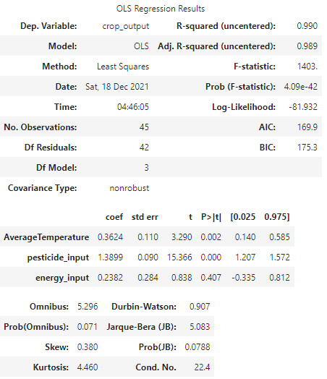

**Figure 1: California; Full Model OLS**

Ordinary Least Squares regression results for Texas suggested that average temperature alone had a positive and statistically significant association with crop output, but not nearly as strong as the same relationship in California. This association, similar to California’s, was also present but weaker with livestock output. Average temperature had a positive and statistically significant association with pesticide and energy input, but less so than California’s, at 0.1695 and 0.3768, respectively. When all three variables are assessed against crop output, energy input is again not statistically significant, and the influence of average temperature lessens, but not by as great a magnitude as for California.

**Figure 2: Texas; Full Model OLS**

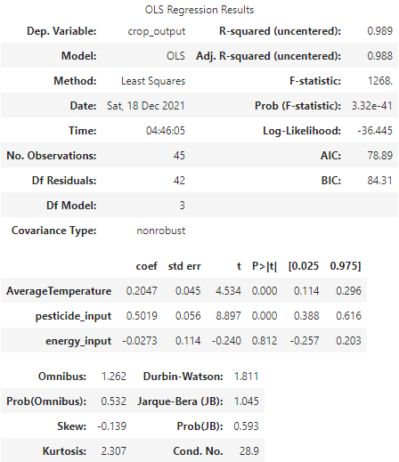

For the state of Nebraska, average temperature alone has a statistically significant relationship to crop and livestock output, with coefficients of 0.4937 and 0.1872, respectively. In a full model with average temperature, pesticide input, and energy input all considered, all three variables are statistically significant in relation to crop and livestock output, and all are positively correlated. This contrasts with California and Texas, whose full models indicate that energy input is not statistically significant in predicting crop or livestock output. Average temperature also has a statistically significant influence on energy and pesticide usage, like California and Texas.

**Figure 3: Nebraska; Full Model OLS**

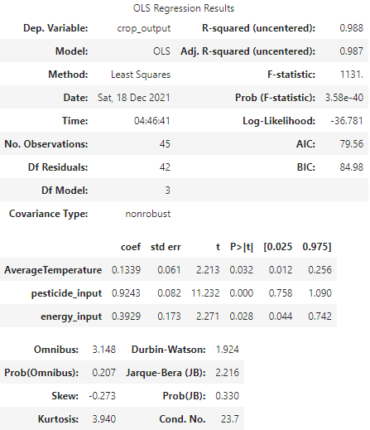

For Iowa, average temperature had a similarly strong, positive, statistically significant relationship to crop output as California, with a coefficient of 0.8496. The difference between this and livestock output is similar to California’s, but at a smaller magnitude of difference. Iowa observes a coefficient of 0.2924 for average temperature as a lone predictor of livestock output. When all three explanatory variables (average temperature, pesticide input, and energy input) are included in the model, all three are statistically significant for predicting crop output, like Nebraska. However, in predicting livestock output, the coefficient of pesticide input is negative, suggesting that less use of pesticide may contribute to greater livestock productivity. Average temperature also appears to have statistically significant relationships with energy and pesticide usage.

**Figure 4: Iowa; Full Model OLS**

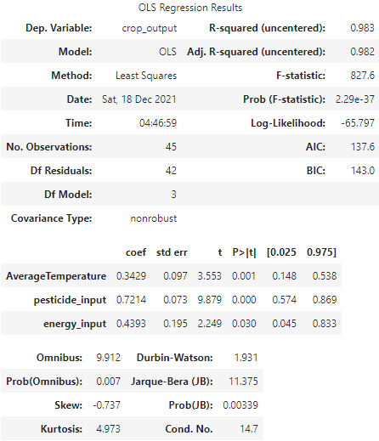

**Figure 5: Kansas; Full Model OLS**

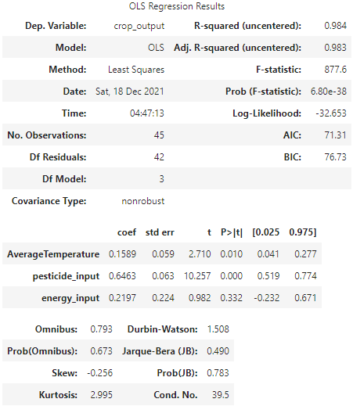

Kansas observes the weakest relationship between average temperature and crop output, although still statistically significant (coefficient of 0.3064). This is similar for average temperature and livestock output as well (coefficient of 0.1146). In a full model with average temperature, energy input, and pesticide input, only two of the three variables (average temperature and pesticide input) have statistically significant influence on crop output. This applies for their relationship to livestock output as well. Average temperature regressed on pesticide input and on energy input (individually) is statistically significant for both response variables, but at lower strengths than seen in the other four states.

The variance inflation factor (VIF) was calculated for all five states. There were no acceptable VIF values, indicating a high level of multicollinearity.

California Texas Nebraska

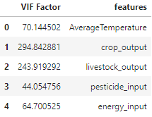 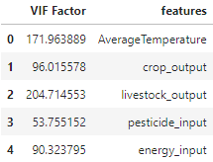 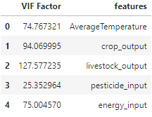

Iowa Kansas

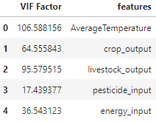 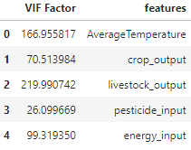

**Figure 6: VIF for five states**

Line plots were developed for each of the five states to illustrate the relationship of average temperature, crop output, livestock output, pesticide input, and energy input, over the time period of analysis (1960 to 2004).

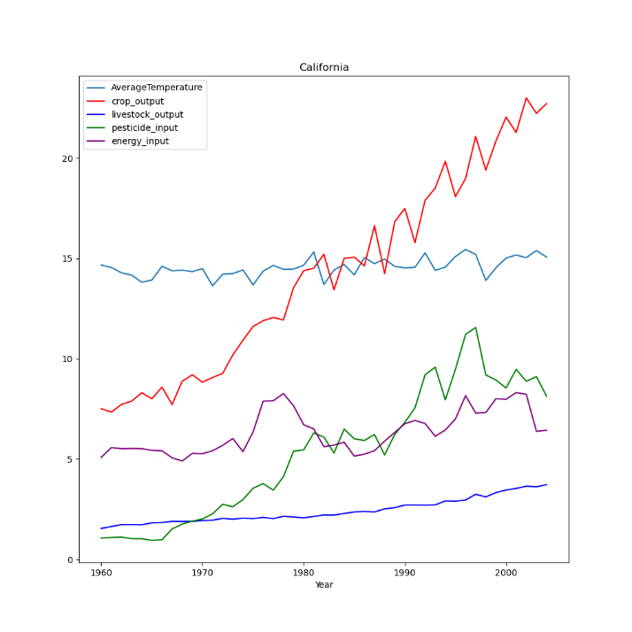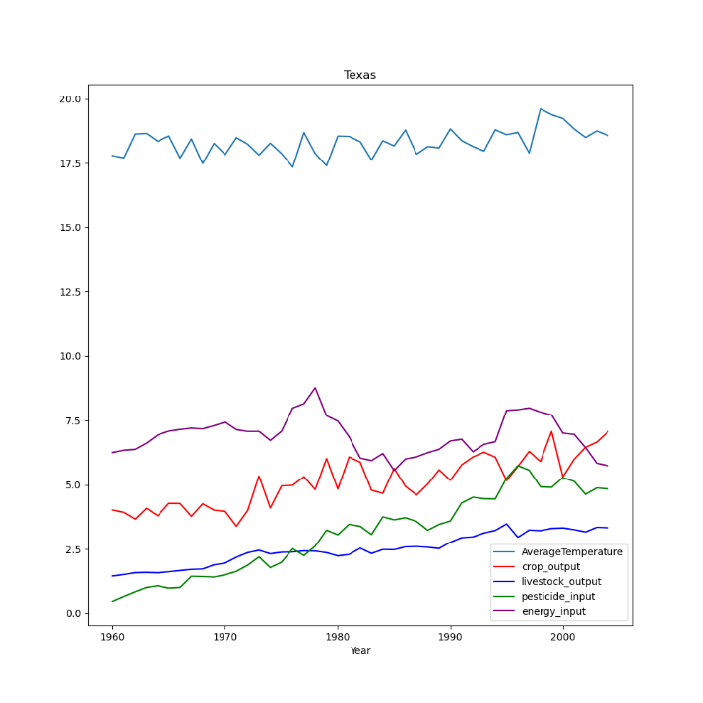

**Figure 7: California Line Plot Figure 8: Texas Line Plot**

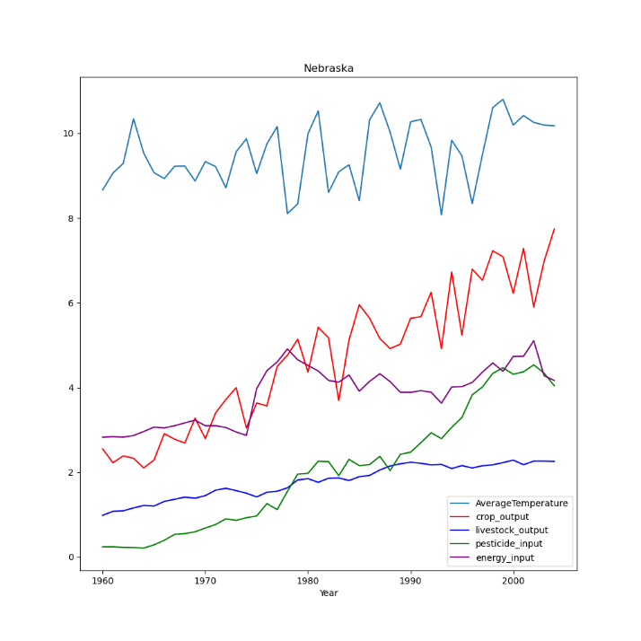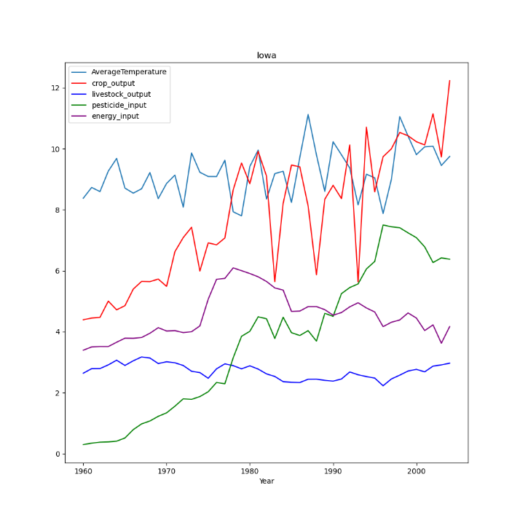

**Figure 9: Nebraska Line Plot Figure 10: Iowa Line Plot**

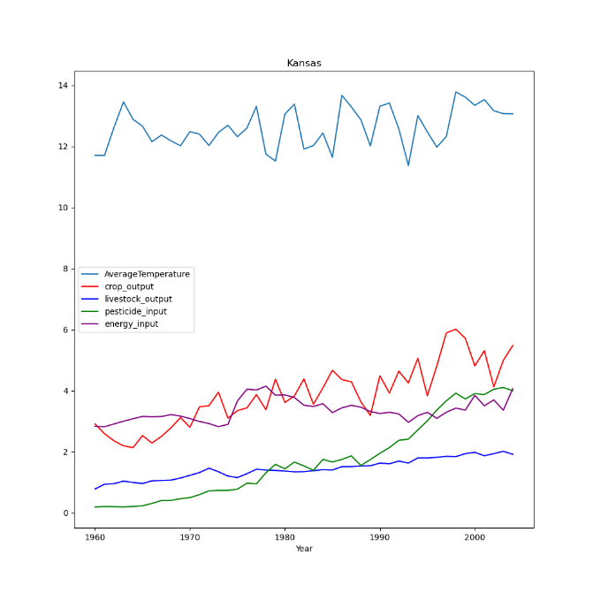

**Figure 11: Kansas Line Plot**

Note that in all five line plots, crop output on average has increased from 1960 to 2004. Iowa appears to experience the greatest fluctuation among the top five agricultural states. Another interesting observation is that Texas is the only state where pesticide usage does not intercept energy usage. Texas energy usage appears to maintain on average, higher values than the other states. There is also an overall incline in pesticide usage as time has passed. Another observation is that in Kansas and Nebraska, there are points in time where energy usage surpasses crop yield. In Texas and Iowa, this is nearly true in a few circumstances as well.

An observation noted from the OLS regression results was that pesticide input was statistically significant in the full model for predicting livestock output. Comparing this observation to the data depicted in Figure 10: Iowa Line Plot, it could be suggested there is a small inverse relationship. Points in time where pesticide usage peaks coincide with troughs in livestock output.

A choropleth map depicting crop output by state, per every five years starting in 1960 shows states becoming more unified in annual crop yield. Rather than a few states starkly falling into higher quantiles of crop output as seen in earlier years, crop output appears to even out across most states, with California being the exception and consistently producing at the top quantile (Figure 12: Crop Output Choropleth).

Average temperatures as depicted on a choropleth map, for contiguous states in the U.S. every five years from 1960-2004 show a subtle increasing trend in temperatures. States in the middle latitude of the U.S. appear to experience greater fluctuations in average temperature, while states in the lower and higher latitudes of the country generally fall in the same or close to the same quantile of average temperature over time (Figure 13: Average Temperature Choropleth).

The bivariate choropleth maps developed in this analysis show the changes in the relationship between average temperature and crop output every five years between 1960 and 2004. The maps support previous observations that the upper and lower latitudes of the U.S. experience less drastic changes compared to the mid-latitude states, where the colors on the map change in saturation more significantly and frequently (Figure 14: Bivariate Choropleth Maps).

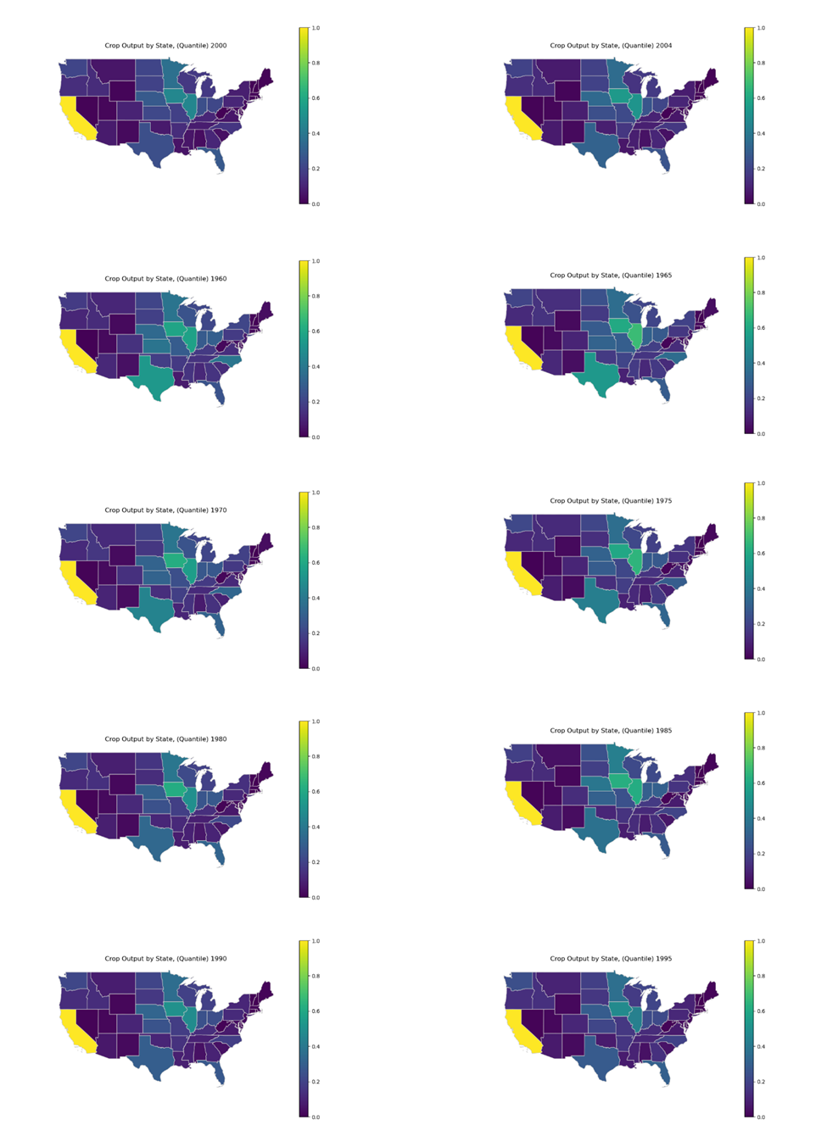

**Figure 12: Crop Output Choropleth**

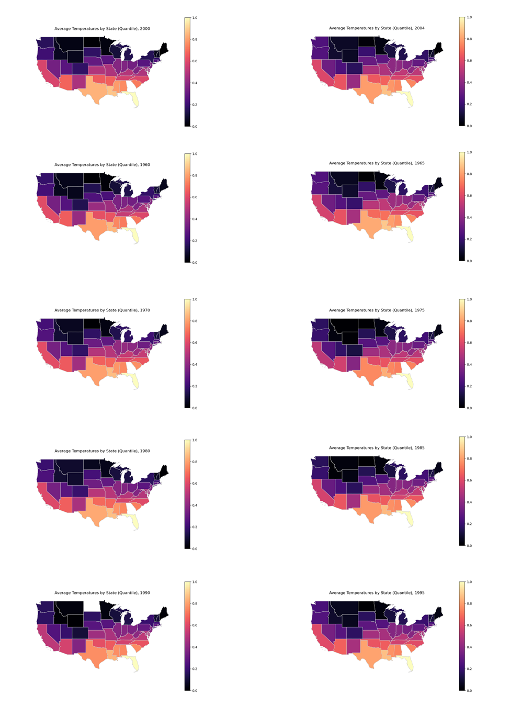

**Figure 13: Average Temperature Choropleth**

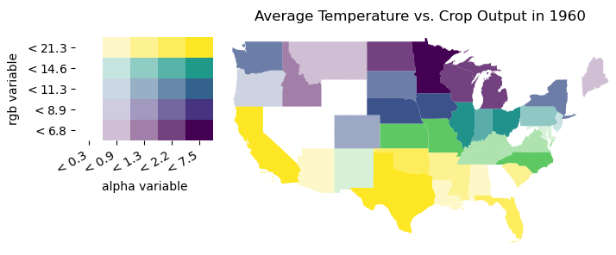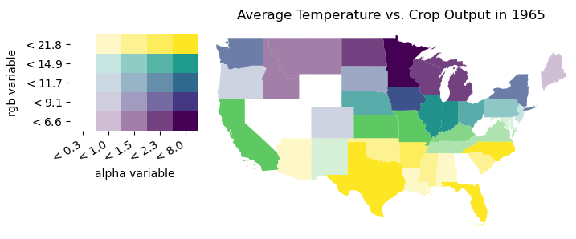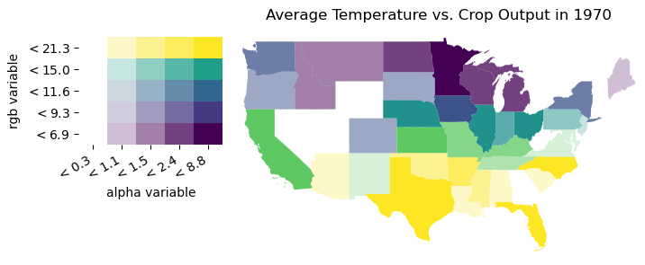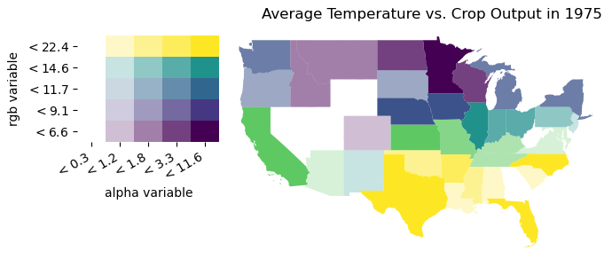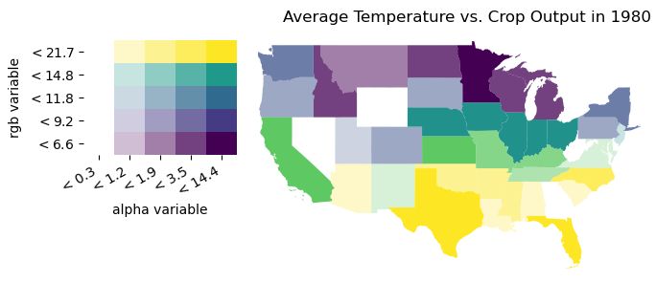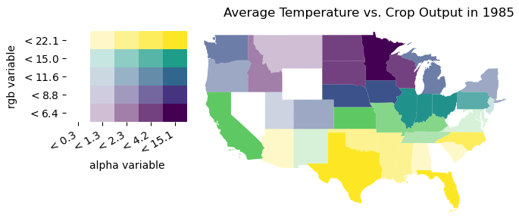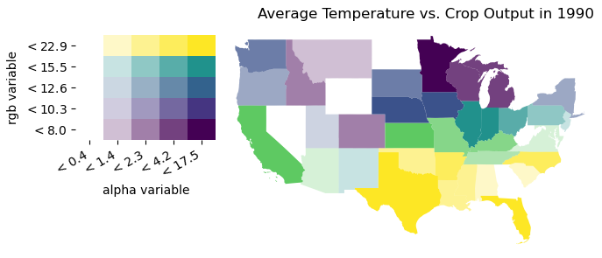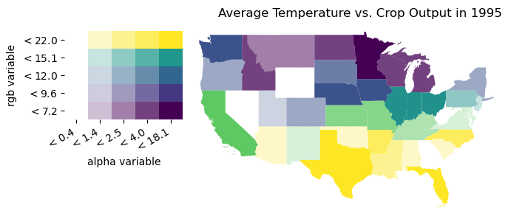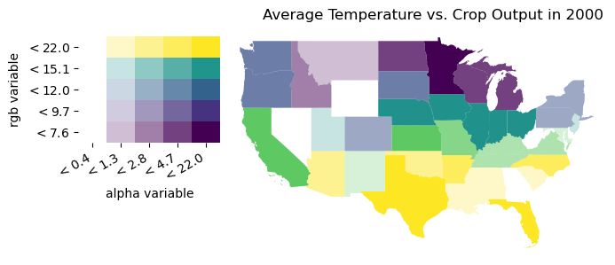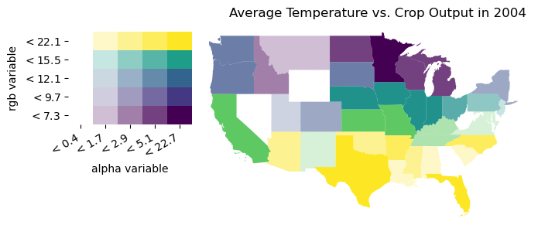

**Figure 14: Bivariate Choropleth Maps**

# Discussion

The relationship between average temperature and crop output was generally the same for all five states; that is, there is a statistically significant, positive relationship between annual average temperature and annual crop (and livestock) yield. However, the interaction of other explanatory variables introduced into this analysis (pesticide and energy usage) varies between the different states. This could be for a number of reasons, to include regional ecology and policy. These are other factors that may explain the interactions between average temperature, pesticide and energy usage, and agricultural production, especially considering the high level of multicollinearity between the variables included in this analysis. More than one of these variables are likely to be influenced by other variables not considered in this analysis, perhaps in similar ways, thus contributing to multicollinearity.

Evidence from OLS regression and spatial analysis suggest that average temperature is a statistically significant influence on crop output as a measure of agriculture production, but is not the sole determinant. In Texas, for example, an observation was made that it was the only state of the top five agricultural states where pesticide usage does not ever intercept energy usage, in this time frame. Additionally, Texas and Nebraska are states where energy usage in agriculture exceeds crop output. This could be due to a variety of reasons, such as differences in energy policy in these states versus other states. It could also be due to the regional ecology and physical geography, where it may take more energy to produce crops relative to other states. This observation is also somewhat seen in Kansas, although not to the same degree, and their patterns and levels of crop production are similar. Geographically, this may make sense – Texas and Kansas are located closely together and therefore may share similar physical geographic characteristics.

In contrast, California’s pesticide usage exceeds energy usage at a certain point. More efficient use of energy or more efficient energy generation methods may explain the reduced need for energy in agriculture. However, pesticide usage in California, as in Nebraska, Iowa, and Kansas alike, intercepts or exceeds energy use at a certain point. This indicates that at some point in time, the need to use more pesticide products was necessary to maintain or increase the level of crop production. In Texas, Iowa, and Kansas, at some points in time, pesticide use exceeds crop output, suggesting that there were periods of time where crop yield suffered due to pesticides. As there is an increasing trend in pesticide use for all states, it could be suggested that there is a greater presence of or opportunity for pests as time progresses. It is not possible to conclude at this scope of analysis, but future analysis could investigate whether this is due to an increase in agriculture activity (more crops thus mean a need for more pesticide products) or if this is due to pest resistance to conventional pesticides, a known issue in the environmental health sector.

Limitations of this study include the length of time of data. Climate change data requires a substantial length of time to establish changes in global temperatures. Forty-five years may not be sufficient in establishing patterns. Other measures of agricultural production could be included for more robust analysis of true agricultural productivity. This goes for climate change indicators as well; another limitation of this study is that it only considers average temperature as a driver for agriculture production, when agriculture is driven by a multitude of other factors, such as precipitation and soil erosion.

Other limitations of this study involve the data quality itself along with spatial variation. With the limited range of data, descriptive statistics or summaries of the spatial data is not sufficient for describing the variation in the spatial data (Haining, 2014). While the maps and graphs help support the geostatistical analysis, an analysis at various scales would be more valuable and this requires richer data. For example, the average temperature is assigned to each state, but this is not truly reflective of spatial variation that exists between and within states. California spans a large geographic area latitudinally and different parts of state experience different climate patterns. Thus, the single average temperature value does not reflect the spatial variation well.

The modifiable areal unit problem (MAUP) is often used in urban analyses and brought up as a concern when census data is used, due to the fact that analytical problems may focus on units that do not match the spatial units of the data used (Fotheringham and Wong, 1991). However, this is an issue that could be applied to this analysis, too. When looking at agriculture productivity on the state level, the analysis ignores the variation in spatial unit sizes of where farms are actually located and the extent to which they span. Temperature is aggregated on a state level as previously mentioned, but this is not truly uniform in real life.

Improvements to this study could involve gathering more data on agriculture, such as location and size of farms. With this data, spatial regression could be used to determine the extent of impact on state agriculture production given climate change indicators and the volume of agriculture activity and reliance. Because environmental factors do not discriminate across state boundaries, spatial regression using this additional data can help with making better predictions about agriculture outcomes because it considers the geographic processes inherent in this use case (Rey et al, 2020). Implementation of density/clustering and k-nearest neighbor functions could aid in understanding whether a concentrated region of agriculture may be more vulnerable to climate change threats than sparse or regions of smaller, individual farms (Rey et al, 2020).

# Conclusion

Agriculture and climate are part of a large feedback system, so a simplified model as was developed in this analysis is insufficient in explaining precisely how temperature alone impacts crop and livestock production. The evidence points to a reasonable conclusion that average temperature is a contributor, but not the only one. Furthermore, other variables involved in climate change (such as precipitation and extreme weather events) may help adjust for variability in the model. It is also important to take note of anthropogenic activity that is difficult to measure quantitatively but may still contribute heavily to agriculture production. Economics and policy also drive agriculture production, and these change state-by-state and year-by-year, driven by other external factors such as global affairs. A holistic approach should be taken when extending this analysis.

# References

Arora, N. (2019). Impact of climate change on agriculture production and its sustainable solutions. *Environmental Sustainability*, 2, 95-96. <https://doi.org/10.1007/s42398-019-00078-w>

Fotherinham, A.S., Wong, D.W.S. (1991). The modifiable areal unit problem in multivariate statistical analysis. *Environment and Planning A*, 23, 1025-1044.

Haining, R. (2014). Spatial Data and Statistical Methods: A Chronological Overview. *Handbook of Regional Science*, 1277-1294. doi: 10.1007/978-3-642-23430-9_71

Lane, D., Chatrchyan, A., Tobin, D., Thorn, K., Allred, S., & Radhakrishna, R. (2018). Climate change and agriculture in New York and Pennsylvania: Risk perceptions, vulnerability and adaptation among farmers. *Renewable Agriculture and Food Systems*, 33(3), 197-205. doi:10.1017/S1742170517000710

Malhi, G., Kaur, M., Kaushik, P. (2021). Impact of Climate Change on Agriculture and Its Mitigation Strategies: A Review. *Sustainability* 13(3), 1318. <https://doi.org/10.3390/su13031318>

OECD. (2016). Agriculture and Climate Change: Towards Sustainable, Productive and Climate-Friendly Agricultural Systems. Retrieved from <https://www.oecd.org/agriculture/ministerial/background/notes/4_background_note.pdf>.

Pryor, S.C., Scavia, D., Downer, C., et al. (2014). Third National Climate Assessment, Midwest. Retrieved from <https://nca2014.globalchange.gov/report/regions/midwest>.

Rey, S.J. (2014). Spatial Dynamics and Space-Time Data Analysis. *Handbook of Regional Science*, 1365-1383. doi: 10.1007/978-3-642-23430-9_78

Rey, S.J., Arribas-Bel, D., Wolf, L.J. (2020). Spatial Regression. Retrieved from <https://geographicdata.science/book/notebooks/11_regression.html#questions>

Tan, G. and Shibasaki, R. (2003). Global estimation of crop productivity and the impacts of global warming by GIS and EPIC integration. *Ecological Modelling,* 168(3), 357-370. <https://doi.org/10.1016/S0304-3800(03)00146-7>

Wanyama, D. (2017). A Spatial Analysis of Climate Change Effects on Maize Productivity in Kenya. *Geography Master’s Theses,* 1. Retrieved from <https://ir.una.edu/gmt/1>.